**ABSTRACT**

An integrated approach to soil testing, soil testing is a fundamental practice in modern agriculture. This study presents an integrated approach to soil testing that combines with traditional chemical analysis of soil. By examining a diverse range of geographical regions. This testing aims to enhance and understand the soil properties, pH and Electrical Conductivity (EC).

This study includes data of 25 soil samples collected from Gurramguda (agricultural sites, land-use histories and farming practices). Standard soil test is performed to determine the levels of essential pH and EC of soil. Soil testing remains a fundamental pillar of modern agriculture, providing essential information for sustainable land management.

Soil electrical conductivity (EC) and pH are two vital parameters that significantly influence nutrient availability of soil. This testing aims to evaluate the relation between soil EC and pH in diverse landscapes of the region. Through extensive filed surveys and laboratory analyses, we seek to understand the properties of the soil. Soil samples were collected at different areas in the region to determine the EC of the soil.

Soil testing analysis were performed using standard methods to determine soil EC, a measure of the soil’s ability to conduct electricity, and soil pH, a measure of soil acidity or alkalinity. The study reveals that areas with higher EC values tended to exhibit lower pH levels, suggesting increased soil salinity, conversely regions with lower EC values typically had higher pH levels, indicating potential alkaline conditions that may limit the availability of essential nutrients of the soil.

In this study Kriging interpolation stands as a valuable geospatial tool for obtaining reliable estimates of unknown variables within spatial domain. Kriging is based on the principle of regionalized variables, where spatial autocorrelation is utilized to assess the spatial dependence of data points.

**INTRODUCTION**

**Soil Testing:** Soil testing is a crucial process used to analyze the physical and chemical properties of the soil to assess its fertility, composition, and sustainability for various purposes. The information obtained from soil testing helps farmers, environmentalists make informed decisions about soil management and treatment. Soil testing helps in soil conservation efforts by providing data on soil properties that influence erosion.

**EC (Electrical Conductivity):** Electrical Conductivity is a measure of the soil’s salinity or the concentration of soluble salts present in the soil solution. EC is typically measured in units of deciSiemens per meter (dS/m) or milli Siemens per centimeter (mS/cm). EC is crucial for determining the suitability of water for irrigation. This measurements can provide insights into soil nutrient status.

**pH of soil**:The pH of soil is a measure of its acidity or alkalinity and is an essential parameter in soil testing. It determines the soil’s ability to support plant growth and influences nutrient availability in the soil. The pH scale ranges from 0 to 14,with 7 being considered neutral. Values below 7 indicate acidic soil, while values above 7 indicate alkaline(basic) soil.

During the site visit focused on soil testing, the visit provided valuable insights into the process of collecting soil samples, conducting analysis and interpreting results. This study includes data of 25 soil samples collected from Gurramguda . As this region stands as a unique place containing availability of various kinds of soils. As a team of 9 students visited the site and collected samples. This is the first ever soil testing survey done in Gurramguda.

**KEYWORDS**

PH, Electric Conductivity, Kriging, Interpolation.

**OBJECTIVE**

* To prepare base map of Gurramguda.
* To conduct soil test and finding pH and EC values.
* Interpolate data and prepare kriging model.

**METHODOLOGY**

**1.Latitude and Longitude:**

Gurramguda village has the global coordinates (17.2945°N & 78.5665° E) lies in Rangareddy district (501510) of Telangana state with coordinates (18.1124° N &79.0913E)

**2.Climatic Condition of the village:**

**i) Temperature, Winds:**

Gurramguda has a unique combination of a tropical wet and dry climate that borders on a hot semi-arid climate. The climate of Gurramguda remains fairly warm through most parts of the year and does not receive much rainfall in the monsoon. The days are hot and dry, usually going up to extreme highs of 40 °C (104 °F), while the nights are cool and breezy. Winds usually bring along clouds of dust, and people prefer staying indoors in the daytime, while the breezes at night are pleasant and clean.

**ii)Precipitation:**

Average number of rainy days is around 61 days. Gurramguda experiences 2 types of rainfall. They are moderate (15.6mm-64.4mm) and Light rainfall (2.5mm-15.5mm).Mean monthly rainfall varies from 142.9mm in July to 2.6mm in January.

**iii)Altitude:**

The city lies in the Deccan Plateau and rises to an average height of 536 m above the sea level. The city lies at 18.1124° N latitude and 78.5665° E longitude. Gurramguda lies in Rangareddy District which is located in the Central Part of the Deccan Plateau.

**iv)Terrain :**

Gurramguda is blessed with a unique landscape – spectacular rock formations which are about 2,500 million years old; among the oldest and hardest rocks in the world. Rocky regions around the city are under obliteration for urbanization. Granite ridges and hillocks weathered into picturesque balancing forms are a part of the Deccan Shield area. Crops are commonly grown in the surrounding paddy fields. The city's soil type is mainly red sandy with areas of black cotton soil. Gurramguda falls in the seismic zone- II[1] and is seismically least exposed to earthquakes. Previously this area was with agricultural lands. Now Gurramguda is occupied with multiple residential colonies.



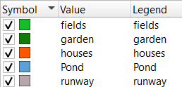

**3.Flow Diagram of Soil Testing:**

GPS coordinates recorded, surface and soil features described.



Photograph sample sites (not to scale)



Collect 200gm (approximately) of various soil samples from soil pits

with clean stainless steel equipment



Transfer sub-sample to clip seal bags and remove air.



(Usage of distilled water, beaker, shaking apparatus and soil samples)

Place 10 gm of soil sample in beaker



Add 25ml of Distilled water in the beaker



Stir for about 30 min with shaking apparatus



After stirring, place the pH meter in the beaker and record values

(After recording pH values, clean the pH meter with distill water)



Now add another 25 ml of Distilled water to the beaker



Stir for another 30 min with the shaking



After stirring, place the Electric Conductivity meter in the beaker and

record the E.C values of the soil.

**RESULTS**

1Krigging:

Through kriging process we were able to successfully place the coordinates accurately in Gurramguda base map. We successfully transformed the base map into kriged map with depicting both the pH values and Electric conductivity.

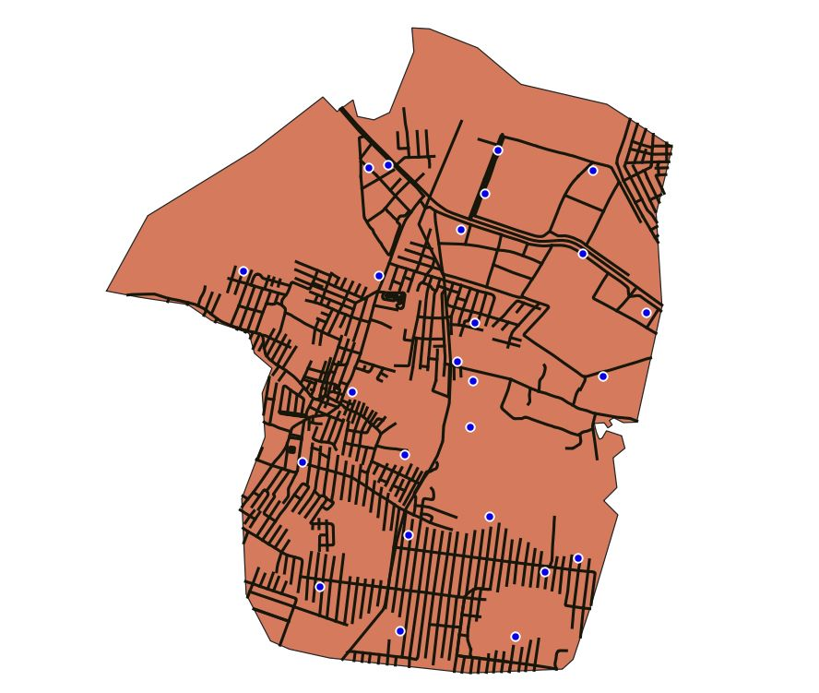

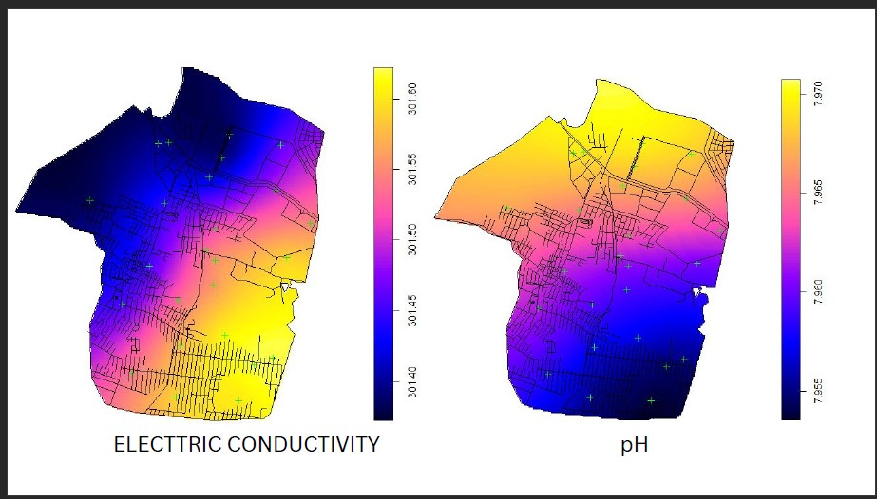

2.pH values of Gurramguda:

Standard pH values-Most soils have pH values between 3.5 and 10. In higher rainfall areas the natural pH of soils typically ranges from 5 to 7, while in drier areas the range is 6.5 to 9.24.A pH range between 5 and 6 is considered ideal for most plants. Acid soils have a major effect on plant productivity once the soil pH falls below 5: pH 6.5 — close to neutral — Optimum for many acid-sensitive plants.

Behaviour of soils in different pH levels

Neutral soils ranges from 6.5-7.5

Alkaline soils ranges >7.5

Acidic soils ranges <6.5

Strongly Acidic ranges <5.5

Out of the 25 soil samples collected and tested,19 of the soil samples belongs to Alkaline medium and of them are belonging to Neutral medium. The observed values of 25 soil samples are listed as (8.1,6.5,7.3,8.1,6.8,7.5,7.3,7.4,7.7,7.8,8.2,7.6,9.3,9.3,8.3,8.5,8,8.6,7.6,7.6,8.1,8.4,8.1,7.6,8.0)

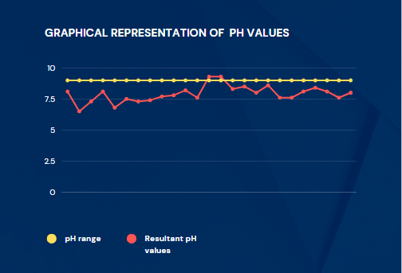

3.Electric Conductivity of soils:

Optimal EC levels in the soil therefore range from 110-570 milliSiemens per meter (mS/m). The observed EC levels of the soil samples from the soil testing procedure are presented through a bar chart below.

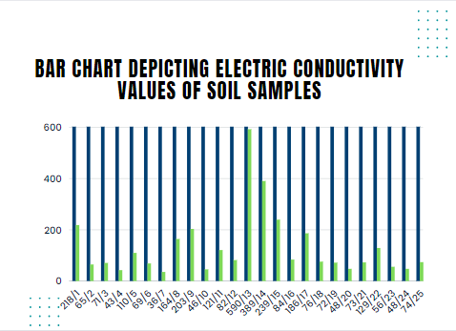

**CONCLUSION**

Soil testing is an inexpensive practice to learn about the ability of soils to support crop growth. We have taken 25 soil samples from Gurramguda village, Ranga Reddy district, Telangana. In soil analysis there are six processes which are soil sampling technique determination of texture of soil, determination of water content, determination of organic matter, determination of soil pH. We have tested 3 different types of soil samples. They are RED, BLACK, CLAY. From different areas (Housing area, Farm, Pond) in Gurramguda.

In the determination of texture of soil, it can be concluded that soil samples from housing area have the highest percentage of stone component whereas soil sample from Form has the highest component of sand. Soil sample from the Pond has the highest percent of Slit and Clay.

In the determination of water content , sample in the pond has the highest water content. Whereas water content in housing area has least percentage of water.

In the determination of organic matter housing area soil has the highest percentage of organic matter whereas in farm area minimum percentage of organic matter. In pond area soil has very least percentage of organic matter.

In the determination of pH level of soil sample, the soil pH values are in the range from 6-9. Most of the soil samples are alkaline soil.

In the determination of EC values (Electric Conductivity): They are in the range from 36 – 590(mS/m). That means the higher the EC, the more negatively charged sites (Clay and Organic particles) there must be in the soil. That means more nutrition levels in the soil. Too low EC levels indicate low available nutrition with low organic matter levels.

Therefore, we conclude that by performing the soil testing, we were able to successfully achieve the true and standard levels of both the pH and Electrical Conductivity.

**REFERENCES:**

1.Library books

2.Newspaper article

3.Internet